Bermuda to British Virgin Islands
Bermuda was discovered in 1505 by Spanish Captain Juan de Bermudez and first appeared on a Spanish chart in 1511. A summary of her colorful and often tragic history can be read HERE.
For the Blue Water Cruisers in all of us, this voyage will inspire the pursuit of a nautical global circumnavigation. Our course will traverse almost 1000 miles of the Atlantic Ocean before entering the British Virgin Islands. From the temperate latitudes to the north, we’ll head almost due south, making best use of the prevailing south easterly trade winds.

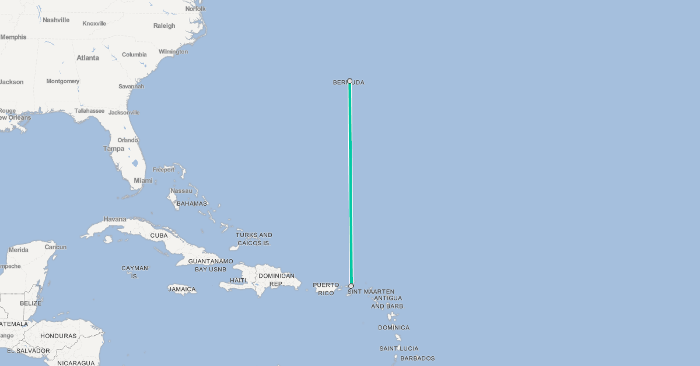
After many days at sea, the Virgin Islands will appear on the horizon just as they did for Columbus, Drake and every mariner since 1492.
Time prevailing we’ll take-in the beauty of the islands, anchoring in secluded tropical coves and snorkeling amongst some of the most diverse corals in the Caribbean. It isn’t called “Nature’s Little Secrets” for nothing.

